**LAB MANUAL**



**ROLLNO:AV.SC.U4CSE24120**

**NAME:REVANTH G**

**SECTION: CSE-B**

**WEEK-1:**

**Aim:** How to install jdk and first program on

printing student details*.*

**Step-1:** Download JDK-21 from oracle website

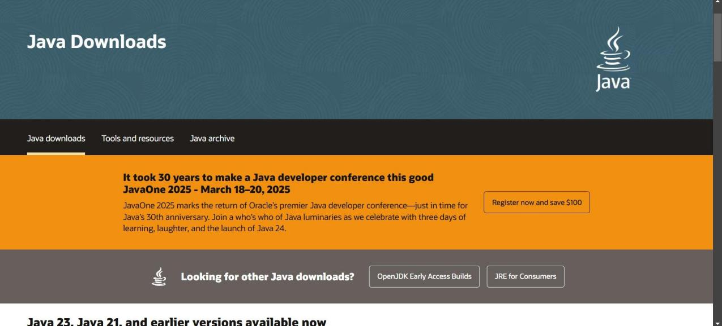

**Step-2:**Install the JDK-21 with accepting terms and

conditions according to the respective windows.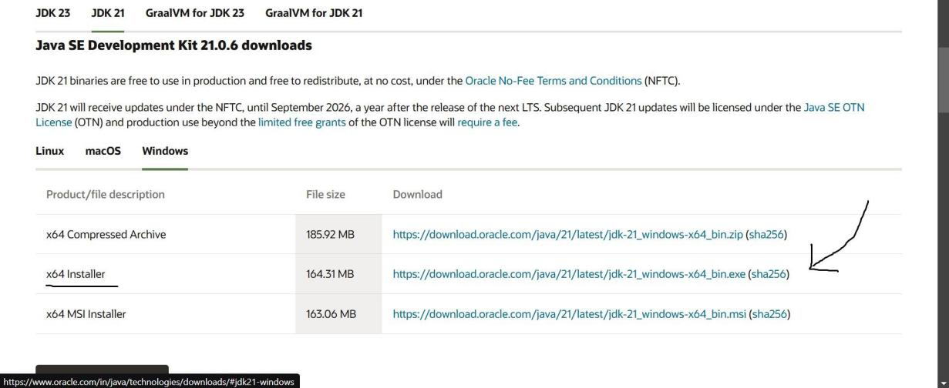

**Step-3**:Setting up environmental variables.

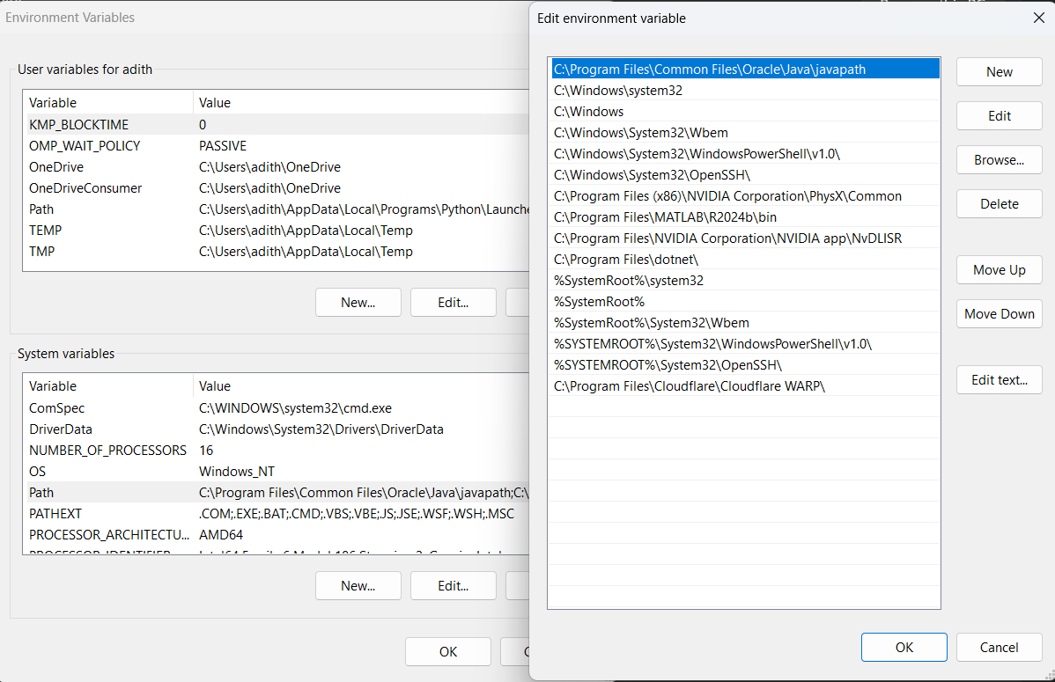

*Windows c -> C-drive -> program files ->Java -

>JDK-21->select bin

*Select and open environmental variable in search

bar-> either select system variables or user

variables-> select path-> click edit->New-> paste

the bin-> finish the setup(apply the changes).

~for verifying the installed version

Open cmd-> type java --version

~command propt

Javac filename.java ->compiling.

Java filename.java ->displaying

**PROGRAM-1(Rectified):**

Step1: create new notepad folder and write the code of java program that prints name , roll number & section of a student.

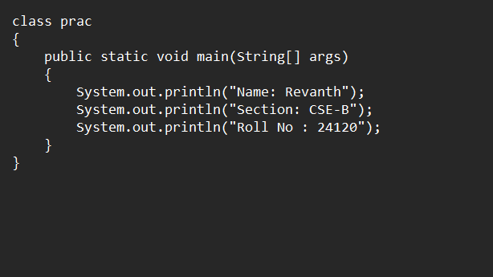

Step2: Save the file as StudentInfo.java and open the notepad file in command prompt and compile javac prac.java.

Step3: So ,we are getting 3 errors which is in the printing statement. Go to notepad and correct the mistake in the printing statement.

Step4: Now save the java file and open the command window and type javac prac .java and compile it.

**Output:**

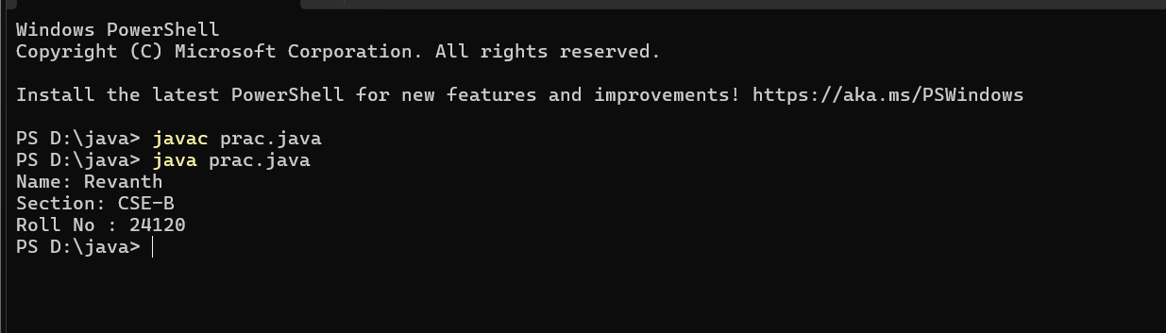

**WEEK-2:**

**PROGRAM-1:**

**Aim:** Write a java program for SI

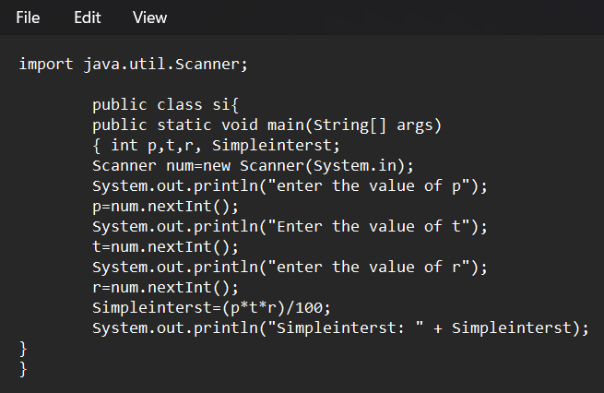

**Output:**

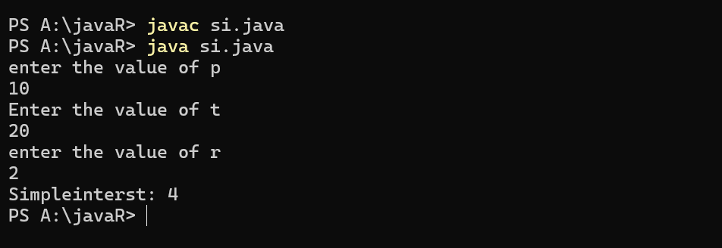

**ERROR TABLE*:***

|  |  |
| --- | --- |
| **Code Error** | **Code rectification** |
| 1.Giving space between next and Double.  2.Not giving parenthesis after closing the input. | 1.Should not give space between next and Double.  2.We must put parenthesis after closing the input. |

**PROGRAM-2:**

**Aim:**Write a program in java for area of rectangle.

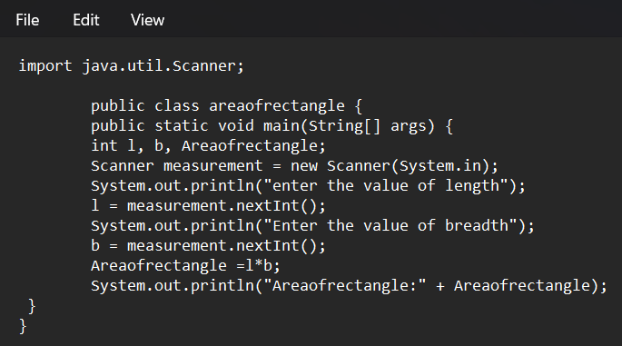

**Output:**

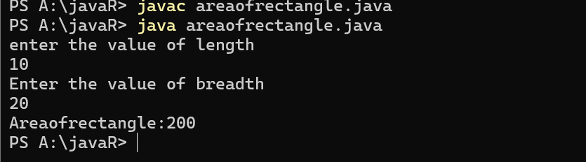

**ERROR TABLE:**

|  |  |
| --- | --- |
| **Code Error** | **Code rectification** |
| 1.While using for iteration, not giving the conditions correctly.  2.Declaring the data type as double instead of int. | 1.We should give iterative statements correctly.  2.We should give the data type as int for integers. |

**PROGRAM-3:**

**Aim:**Write a program in java for area of triangle using heron’s formula.

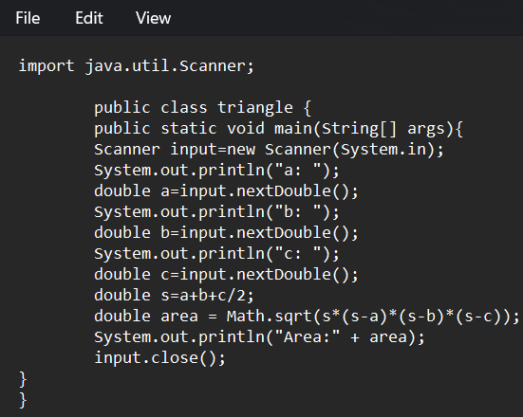

**Output:**

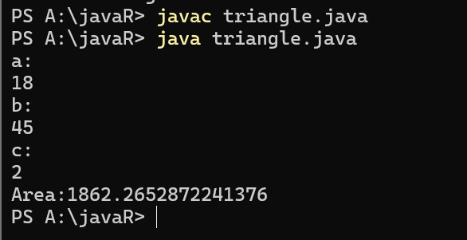

ERROR TABLE:

|  |  |
| --- | --- |
| **Code Error** | Code rectification |
| 1.While printing the variable not giving + sign.  2.Not closing the scanner. | 1.We should give correct indentation.  2.Closing the scanner is must. |

**PROGRAM-4(a):**

**Aim:**Write a program in java for converting temperature from celsius to fahrenite.

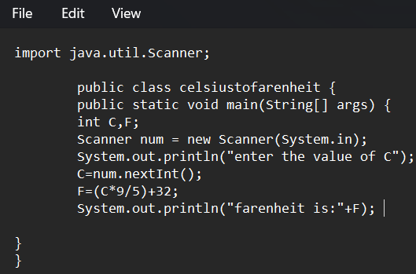

OUTPUT:

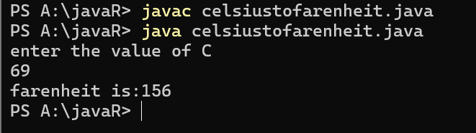

**PROGRAM-4(b):**

**Aim:**Write a program in java for converting temperature from fahrenite to celsius.

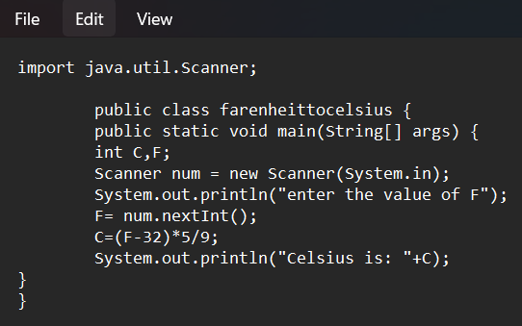

**Output:**

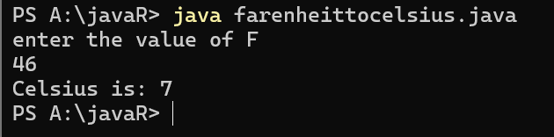

**ERROR TABLE:**

|  |  |
| --- | --- |
| **Code Error** | **Code rectification** |
| 1.While printing the variable not giving + sign.  2.Not closing the scanner. | 1.We should give correct indentation.  2.Closing the scanner is must. |

**PROGRAM-5:**

**Aim:**Write a program in java for factorial of a number.

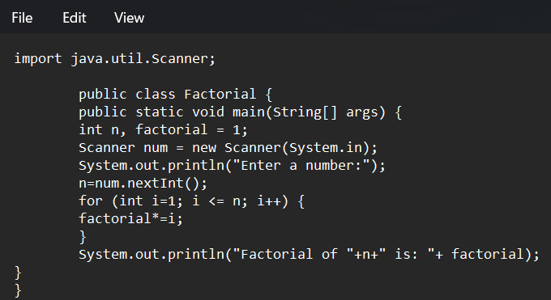

OUTPUT:

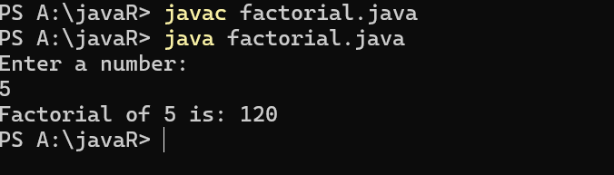

ERROR TABLE:

|  |  |
| --- | --- |
| **Code Error** | **Code rectification** |
| 1.While using for iteration, not giving the conditions correctly.  2.Declaring the data type as double instead of int. | 1.We should give iterative statements correctly.  2.We should give the data type as int for integers. |

**PROGRAM-6:**

**Aim:**Write a program in java for fibonacci series.

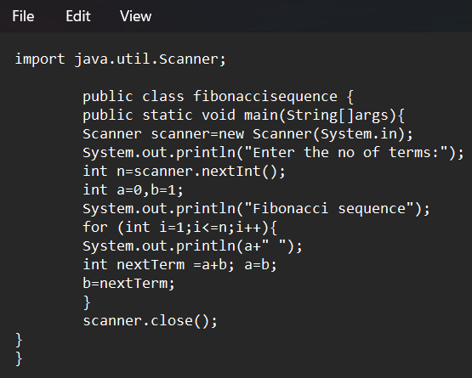

OUTPUT:

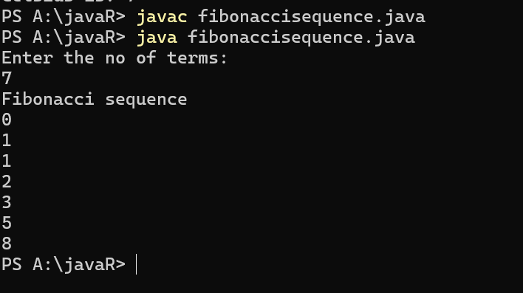

ERROR TABLE:

|  |  |
| --- | --- |
| **Code Error** | **Code rectification** |
| 1.Giving space between next and Double.  2.Not giving parenthesis after closing the input. | 1.Should not give space between next and Double.  2.We must put parenthesis after closing the input. |

**Week 3**

**Program 1:**

**Aim :** Write a java program with the following instructions

1. Create a class with name “Car”
2. Create 4 attributes named CarColor,CarBrand,Fueltype,Miliage
3. Create 3 methods named Start,Stop,Service
4. Create 3 objects named c1,c2,c3
5. Create a constructor with parameters CarColor,CarBrand,Fueltype,Miliage

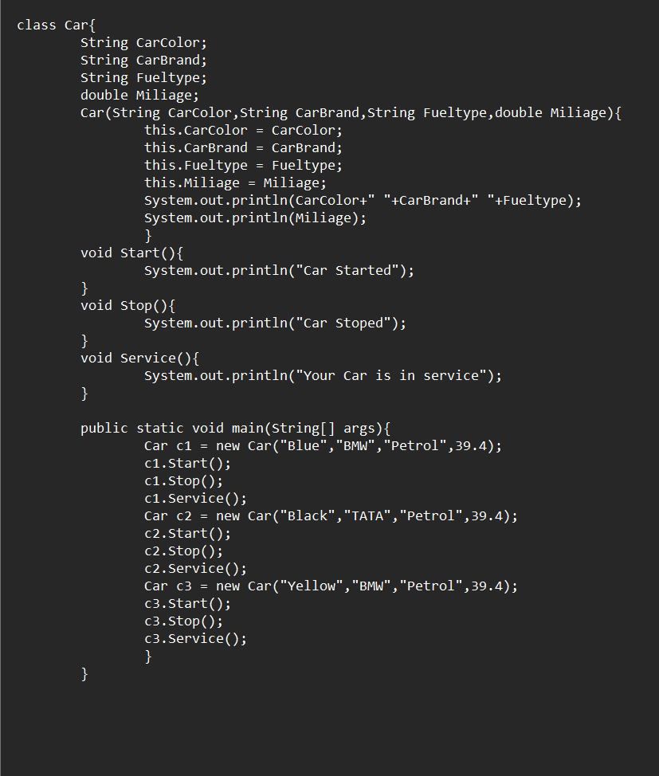

**Output :**

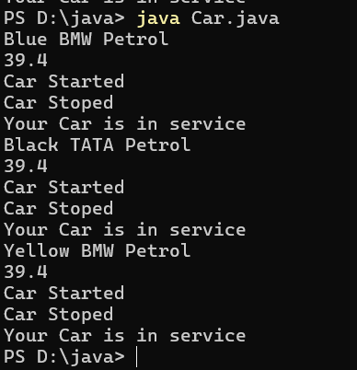

ERROR TABLE:

|  |  |
| --- | --- |
| **Code Error** | **Code rectification** |
| 1.I have kept ‘,’ between variables in print statement | 1.Insted of ‘,’ we should use ‘+’ between  variables in print statement |

**Class diagram:**

|  |
| --- |
| **car**  **-----------------------**  **-car_color:string**  **-car_brand:string**  **-fuel_type:string**  **-milage:double**  **----------------------**  **+start():void**  **+stop():void**  **+service():void** |

**Program 2:**

**Aim:** Create a class named bank account with methods Deposit,withdraw,were the deposit method should accepts a parameter and when this method is called the deposited amount should added to current balance, in addition to that when a withdraw method is called it has to verify where current balance, if current balance is less then withdraw amount , then “There are insufficient funds” message should display.

🡪Use the constructor to display the details of the customer,(Name,AccountNumber,IFSE,Branch)

🡪Also Create two customer objects

**Program:**

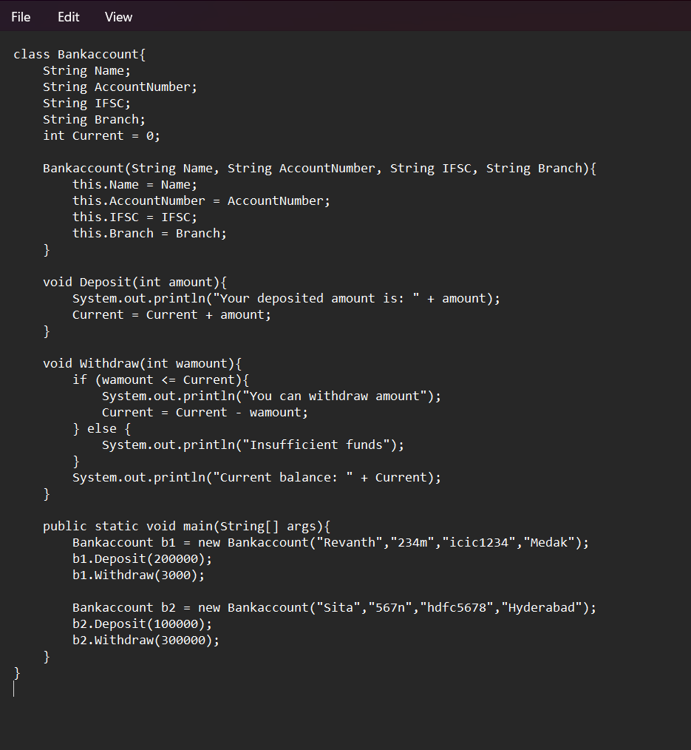

ERROR TABLE:

|  |  |
| --- | --- |
| **Code Error** | **Code rectification** |
| 1. The condition checking in the withdrawal amount should be <= | 1. Change the condition to correct form |

**Class diagram:**

|  |
| --- |
| **BankAccount**  **----------------------------------------------------------**  **-balance: double**  **----------------------------------------------------------**  **+BankAccount(intialBalance: double)**  **+deposit(amount: double):void**  **+withdraw(amount: double):void** |

**Output:**

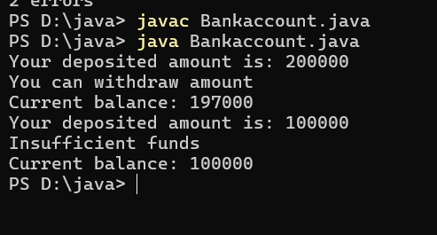

**Week 4:**

**Program 1**

**Aim:** Write a java program with class named ‘Book’ the class should contain various attributes such as title ,author, year of publish it should also contain a constructor with parameters which inisalizes title, author, year of publish .Create a method which display’s the details of the books ,Display the detailes of two books i.e create two objects and display their detailes.

**Program:**

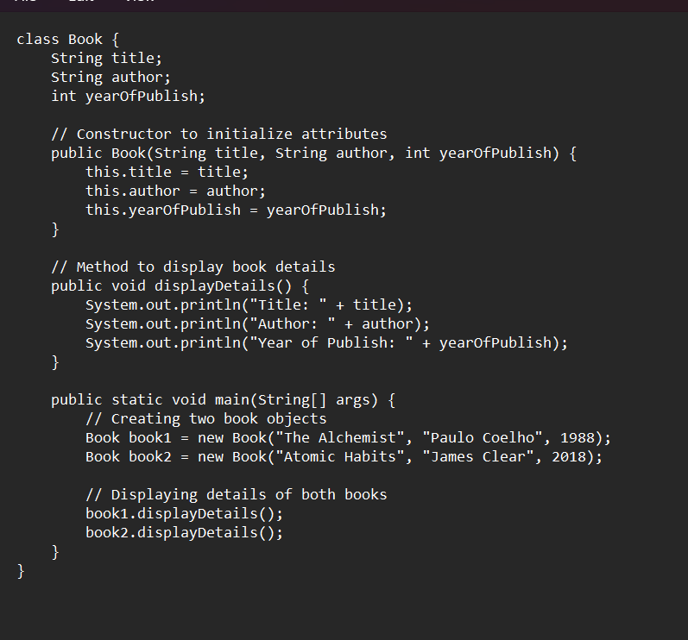

**Output:**

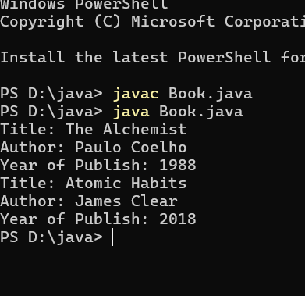

ERROR TABLE:

|  |  |
| --- | --- |
| **Code Error** | **Code rectification** |
| 1. No error occured | 1. No error occured |

**Program 2:**

**Aim:** Create a java program with class named “MyClass”, with a static variable count of int datatype and inisalized to zero and a constant variable ‘pi’

of type “double” insilaize to 3.145 as attributes of the class, Now define a count variable each time an object of “MyClass” is created.Finally print the final values of count and ‘pi’ variables.

**Program:**

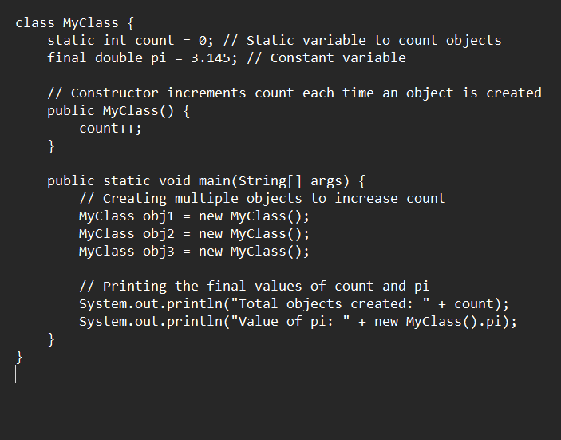

**Output:**

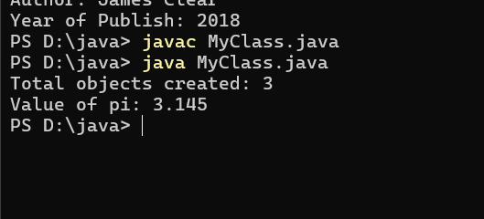ERROR TABLE:

|  |  |
| --- | --- |
| **Code Error** | **Code rectification** |
| 1. No error occured | 1. No error occured |